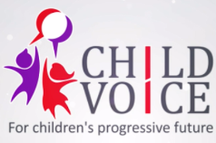

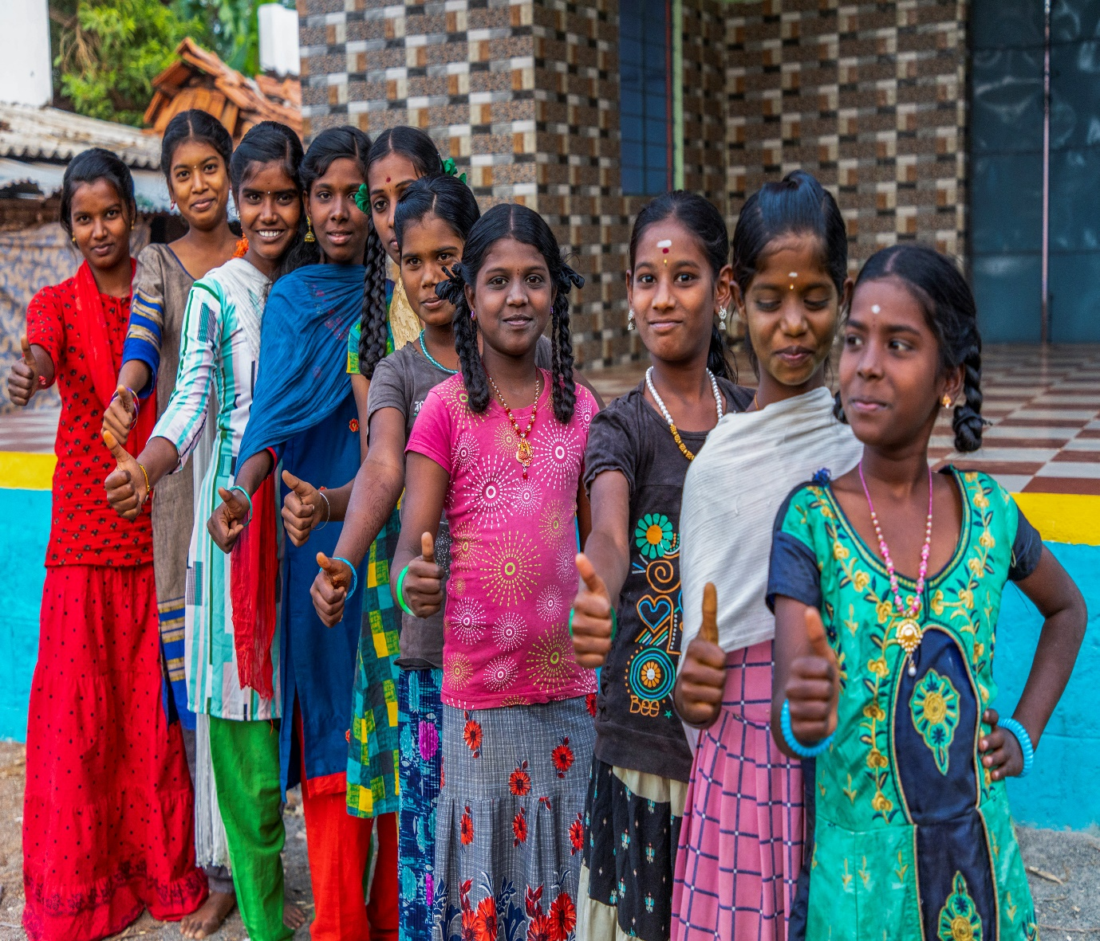

ANNUAL REPORT 2022-2023
CHILD VOICE
Dindigul District, Tamilnadu

CHILD VOICE
Child-based welfare interventions for holistic children development.
Child Voice is a non-profit, non-governmental organization working towards the sustainable development of children and their families. A UK-based volunteer, who witnessed the pathetic condition of tribal children living in the Kodaikanal region, became the main reason behind the existence of this organization. He seeded the necessity for an organization that would work exclusively for the welfare of the children. Ever since then, our organization became a voice for children living in absolute poverty and negligence. We initiated our activities by providing healthcare facilities for children living in tribal areas. Later on, we expanded our activities and supported many children by giving them access to education, and healthcare facilities, developing their skills, and awareness programmes, and rescuing them from child marriage, child labour and bonded labour practices. Through our process of rescuing and rehabilitating children, we realised that their parents need sustainable livelihood opportunities to support their children further. So, we provided livelihood support for the tribal community and Entrepreneur Development Program Support for the target children's families for alternative income. We financially strengthen the families of children so that they are not caught up in the vicious circle of poverty. Our target programmes have benefitted a lot of children and their families in achieving a better standard of living.
Vision
A progressive Society involving, Promoting and safeguarding the rights of Children.
Mission
- To empower underprivileged children and to ascertain their rights, particularly the protection and participation rights.
-To establish sustainable communities that prioritise child rights.
- To bring policy-level changes for the implementation of children’s rights through advocacy and networking.

Objectives
- To identify and map school dropout children, runaway children, street children, children at risk and child labourers in the operational areas of Dindigul, Palani and Kodaikanal.
- To protect school dropout children, runaway children, street children and child labours from economic exploitation and protect them against all forms of abuse and discrimination.
- To facilitate and create opportunities for their skill development and economic independence by enhancing them through capacity-building programs enabling them to be a dignified and resourceful citizen.
- To equip the children with life skills for living in harmony with other children and to facilitate their learning opportunities and enhance their capacity towards increasing future employment opportunities.
- To create opportunities for children to showcase their talent and identify and promote leadership qualities and enable increased child participation through the collective forum.
- To empower children sangams and federation to identify child rights violations and enable them to address the issue by themselves and to ascertain their rights.
- To promote gender equity and equality in schools and communities.
- To join hands with civil society organizations in campaigns and solidarity actions for influencing policy-level changes.
- To promote community ownership in operational areas ensuring child protection.
- To establish Child Voice as a resource organization in the field of child rights and effectively carry out advocacy and lobbying both at the micro and macro level jobs.
Policies
- Administration policy
- Anti-corruption policy
- Child Protection policy
- Safeguarding policy
- Finance policy
- Governance policy
- Whistleblowing policy
Child Voice Board of Trustees
Mr A. Henry Sahayaraj - Founder Trustee
Mr S. Annadurai - Managing Trustee
Mr Anand - Finance Trustee
Mrs Subbuthai - Trustee
Mrs Aarthi - Trustee
Child Voice Office Team
M. Arunraja - Programme Manager
S. Uma Maheswari - Finance Manager
V. Sivanagajothi - Field Co-ordinator
T. Alagurani - Field Co-ordinator
A. Mary Jenifer - Field Co-ordinator
S. Saratha - Field Co-ordinator
A. Indra - Field Co-ordinator
J. Arul Selvi - Field Co-ordinator
G.Jenifer Mary -Project coordinator, HRF Project
G. Rama Jeyam – CRE coordinator
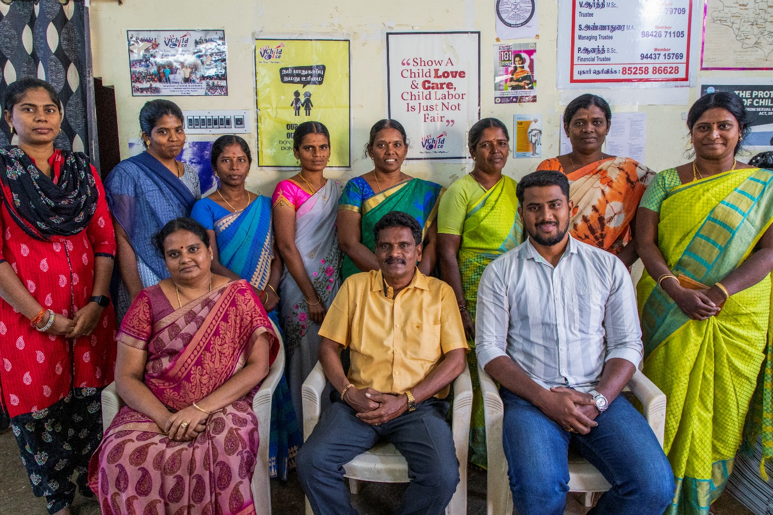
Child Voice Field Team
40 Facilitators are working in 40 working villages under Nilakottai Block in Dindigul District, Tamilnadu.
Highlights of The Programs:
- Health Camps are conducted in 7 villages and 4 Mills covering 2618 Beneficiaries.
- 15 Children and 10 women are supported through Counselling and Mental Health Services.
- 11 School dropout children are identified and enrolled in Schools.
- 1501 Children are supported through Community Resource Centre activities.
- 918 girls are supported through 60 AAG group meetings /SMS Priya Weekly Campaign and Discussion.
- Child Voice gave education support 108 Adolescent girls.
- 721 Boys are supported through 40 ABG group meetings.
- 577 members are supported through 40 CSG group meetings.
- 517 members are supported through 40 WSG meetings.
- 160 members are supported through 16 Mill-based WSG meetings.
- 1107 members are supported through 88 SHG group meetings.
- 90 CSG members are trained on the CSG federation at the Block level.
- 1 Block-level Community Support Group Federation Initiated.
- 13 Village Panchayat VLCPCs are activated.
- 51849 members are supported to receive social security schemes.
- 22 PRI members/Village Volunteers trained on the registration of migrant data at the Panchayat level.
- 16 mill workers are trained on Internal Committee Process and POSH Act 2013.
- 3525 members are involved in the observation of important days.
- 1 policy level change has been brought by Community Support Group members at the District level.
- DCPU letter carts comping 7 Govt. schools in Nilakottai block.

Activities
Community Resource Centres:
Child Voice runs Community Resource Centres for vulnerable children in 40 working villages in Nilakottai Block. This CRC acts as a resource centre for children coming from illiterate backgrounds, apart from this, it also acts as a centre where people looking to avail of government schemes are helped in the process. A total of 1501 (889 girls and 612 boys) Children benefitted through our CRC.
Community Groups
Adolescent Girls Group & Adolescent Boys Group:
60 Adolescent Action Groups (AAG) and 40 Adolescent Boys Groups (ABG) are formed in 40 villages in the Nilakottai block where Child Voice is operating. A total of 918 adolescent girls are members of the Adolescent Action Group, and 721 adolescent boys are members of the Adolescent Boys Group.
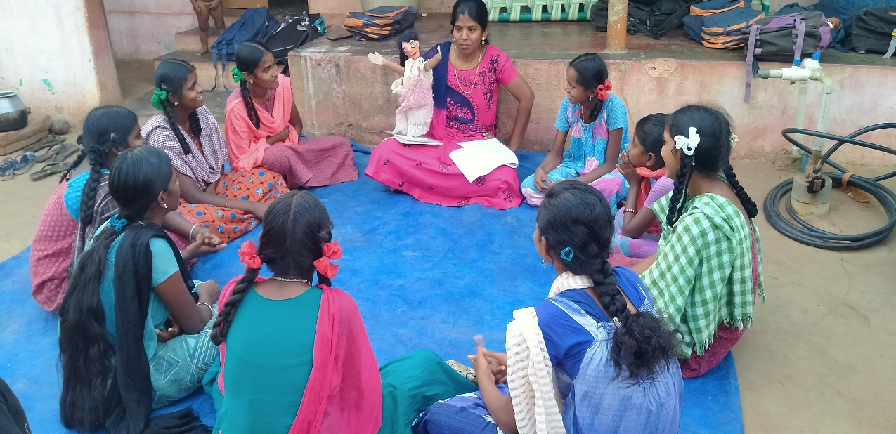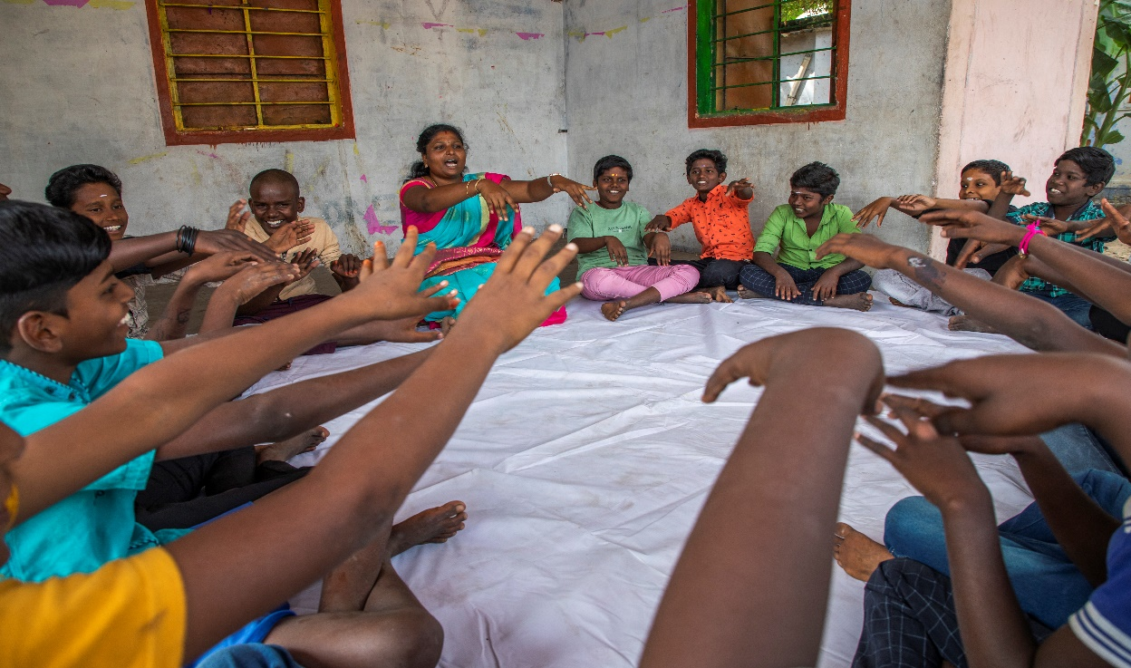

Adolescent action group (AAG) members from one village to another village visited each other and interacted with them. It was a great exposure visit to the AAG group’s members for their knowledge sharing and knowledge of best practices. The purpose of the visit was to discuss the effective use of Child Line Number 1098 to stop child marriage, lessons learnt through the Unnai Ne Arivai Book, Major challenges faced by adolescent action group members during the lockdown pandemic situations, Situational analysis of the school dropout especially talked about the practice of seasonal child labour system in the villages due to school shut down in lockdown days, Online classes impacts and addiction of mobile phone by peer group members, knowledge shared about the POSCO act, Importance of Nutrition food, Safe hygiene practice during mensuration time and recalling of Call me Priya (Film Based Curriculum Book ). This meeting was very insightful and gave the confidence all the AAG members to become very confident to work in a group work towards the empowerment of adolescent girls to protect them from risky situations. As a result of these interaction meetings, AAG members has become a member of the VLCPC of Child Voice working village at Nilakottai Block.
During this training period, 2 training were conducted and 60 AGG and ABG participated in this program. Program Manager and Field coordinator participated in the training programs. In addition, Mr Vignesh resource person conducted the training program during the training programs the following topics were covered a). Child Rights, b). Importance of Education, c). Importance of group formation, d). Life skill, e). Group activity.
Community Support Group
The community support group is a forum of people formed to address the issues such as child marriage, violence against women with the help of Child Line 1098, and emergency helpline services for women. We approach the concerned families and give counselling to help them out of their problems. A total of 513 members are in 40 community groups in 40 villages of Nilakottai Block.
CSG Board opening:
- Community Support Groups in our working 30 villages placed an awareness visibility board in their villages and ensured that Child Marriage, Child labour, School dropout, and bounded labour are not allowed in our villages. The members belonging to AAG, ABG and CSG created awareness among the entire village people to avoid /prevent the issues of Child Marriage, Child labour, School dropout and bonded labour. The awareness visibility board was opened by Panchayat leaders, Village administrator officers, and Police inspectors the keynote speech was addressed by Project Director, Project manager was present at this event and spoke about the prevention of early Child marriage, Child labour, School dropout, and bounded labour. And all the village people take a pledge: “In our village, we were not allowed Child marriage, Child labour, School dropout, and bounded labour”.
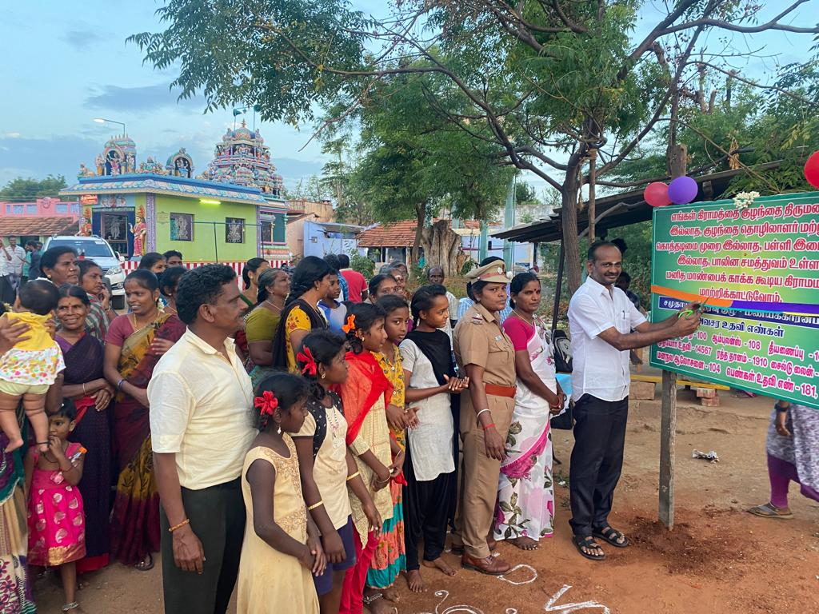
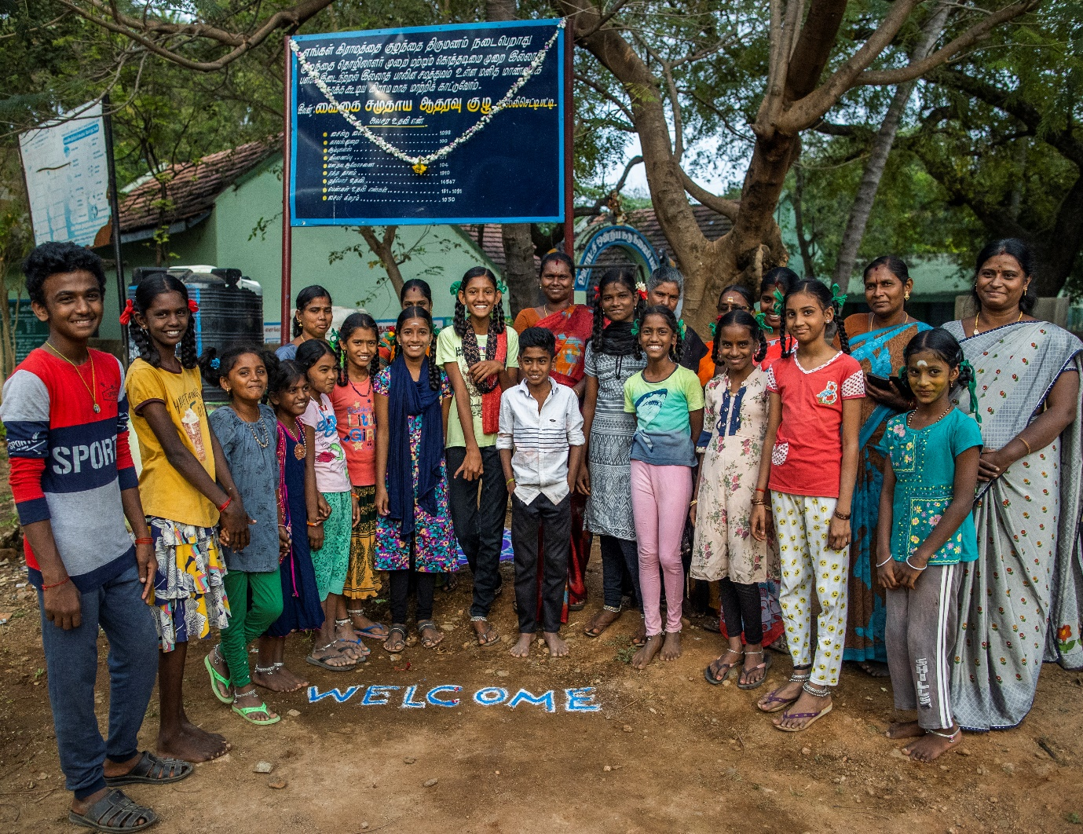
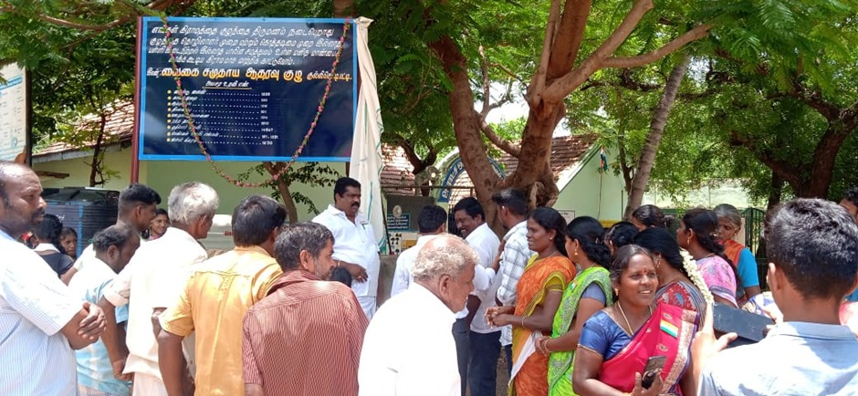
CSG bank account:
- In working villages, 27 community support groups have Society bank accounts. Past monthly savings by the groups saved one lakh nineteen thousand four hundred rupees in their accounts.
- In the Pottichettipatti and Uchanampatti village’s CSG bank accounts, they have twenty thousand six hundred in their account. So, the bank is ready to give loans up to ten lakhs in the scheme of (TADHDCO) Tamilnadu Adi Dravider Housing and Development Corporation.
- In Kamachepuram and Maniyagaranpatti villages CSG bank accounts, these two villages have bank accounts in the town panchayath society bank so the town panchayath banks gave subsite money of Ten thousand.
CSG members together:
- A government liquor store was near the Government Kallar Higher Secondary School in the Anaipatti area of ​​Nilakottai Circle. So, the alcoholics mocked the school boys, girls and women going there and burnt the bottles. Due to this, the passers-by used to go there with fear. Knowing this, the community welfare committee of the people of Mettupatti, Sivagnanapuram, KundalaPatti, Sirunayakkanpatti, and KullichettyPatti, sent many petitions to the government officials, the police department and the education department. Carey suggested that the liquor store should be moved to another location after conducting a site inspection. Then on that basis, it was immediately transferred to another place. Now the students and women who pass that way are going without fear.
- CSG federation leaders and CSG team members petitioned the District collector’s office for Road and Drinking Water facility, an individual Ration shop for the village, Need Govt. a higher secondary school in nilakottai for girls, to stop substance abuse among adolescent boys in the nilakottai area. The petition from the following working villages avarampatti, sandalarpuram, s.mettupatti, kullichettipatii, musuvanuthoor, kokkupatti, kattunayaganpatti and maniyagaranpatti villages, now they got the Road and Drinking water facility and ration shop in the village.
- Child Voice is successful in preventing child marriage and school dropouts in 14 village panchayaths in Nilakottai blocks. Due to the trust built and strategic intervention, 14 village panchayaths are declared as `Child Marriage Free Villages by the Grama Panchayats in the Nilakottai blocks. The village Panchayat also passed a resolution in this connection during the Grama Sabha meeting.
Block-level Interface meeting:
- A program was held at the Block Development Office, Nilakottai area with the Panchayat leader, School teachers and Village administration Officer on behalf of the government agencies serving the children. The meeting was attended by our CSG federation representative and volunteers from the villagers. At this meeting, the villagers talked about the needs of their village. In this, they demanded that the government higher secondary school for girls because Nilakottai block has only one Government aided school for girls. The BDO Officer accepted the request and submitted the petition to the Regional Development Officer along with the villagers. Later it was continuously followed by the panchayat leader. The result is now planned for a new higher secondary school for the Nilakottai block.
Entrepreneur Development program:
- For the entrepreneur development program, we selected 36 women from the 10 villages, following the criteria 1. young widow, 2. Destitute women, 3. Age below 40, 4. Mill worker or survivor. We gave economical support to the women according to their business. For example, if a woman wants to do a tailoring shop we support buying a sewing machine, if a woman wants to open a flour shop we support buying a flour machine.
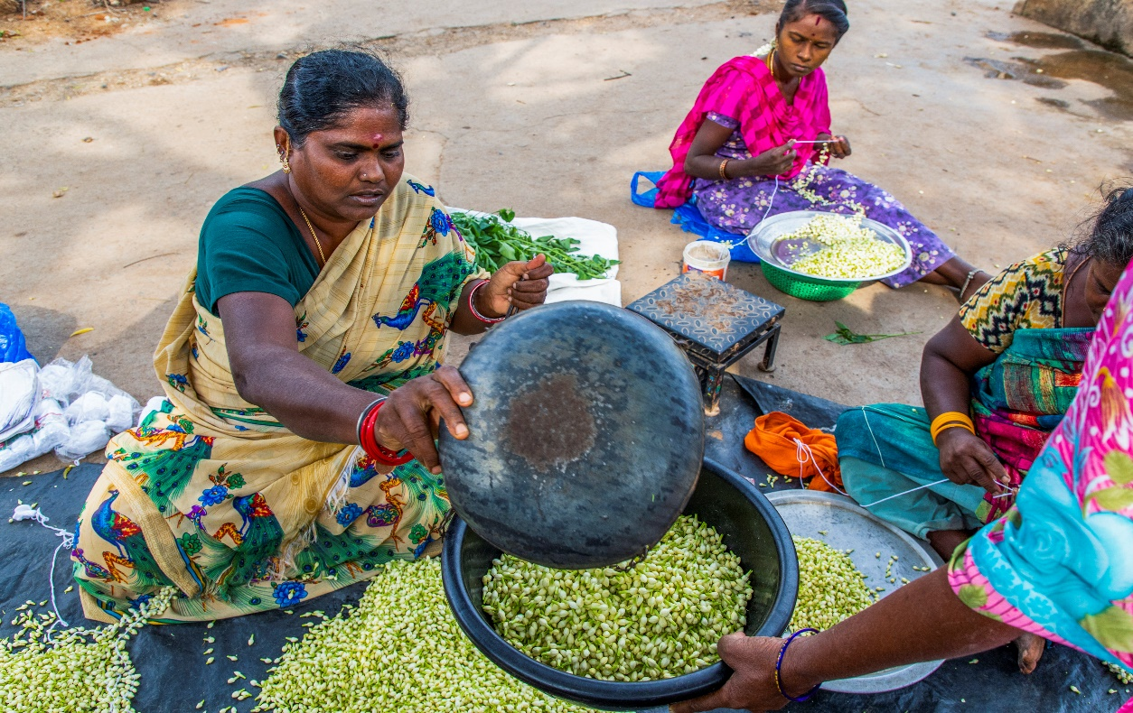
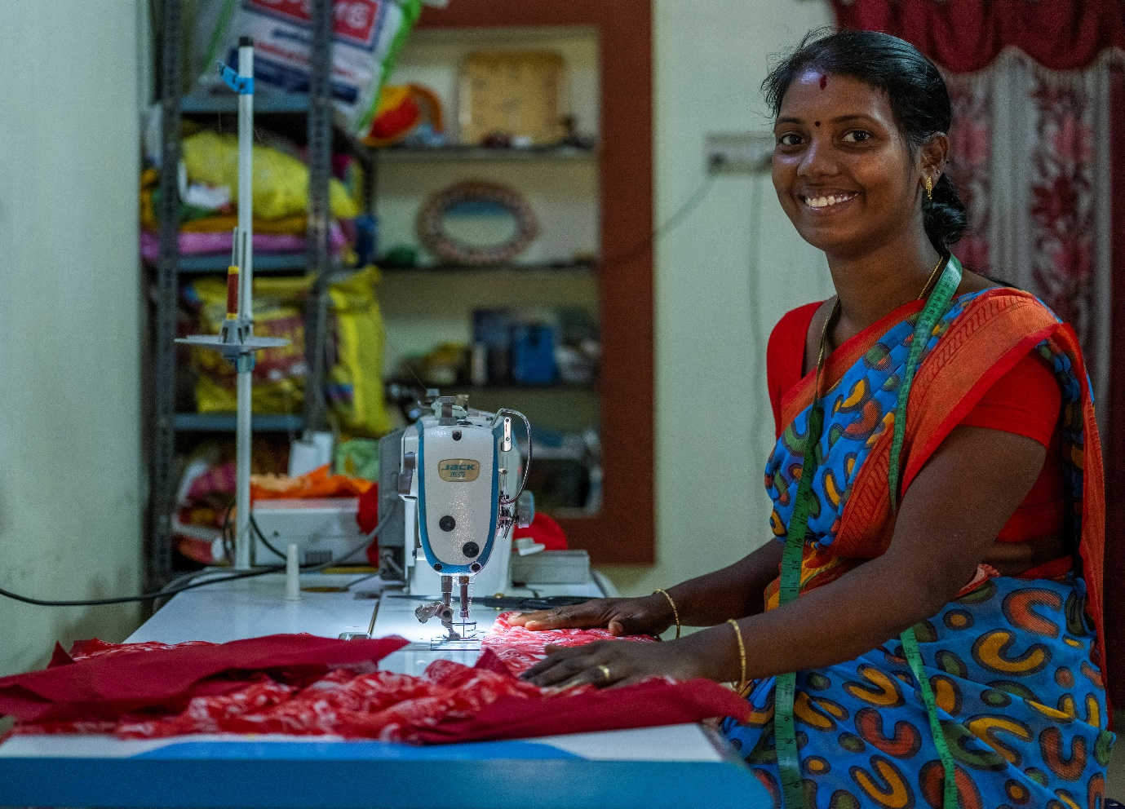
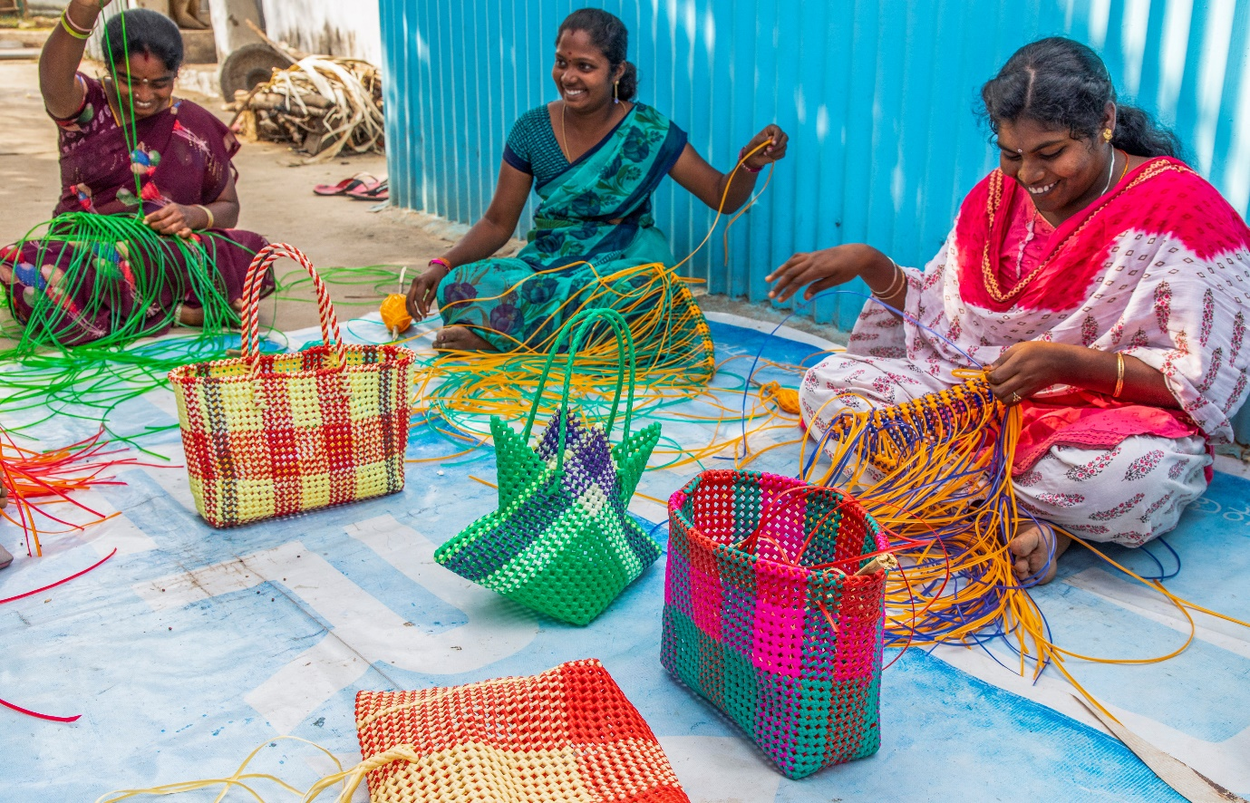

Workers support Group
- Child Voice formed 40 workers’ support groups to help women and adolescent girls working in the textile and garment industries. Internal Compliance Committee is formed in the companies to address sexual harassment in the workplace. Totally,517 members in 40 Villages and 160 members inside mills have joined this group. The worker’s support group was started through the Child Voice Nilakottai. When the group members did not know the complete information about PF and ESI, now they became fully aware of the rights of the mill workers. Mill workers learned how many hours to work in the mill, and how much they would be paid if they worked extra hours. They learned about safety equipment, obtained this from the company, and understood that mill workers should check their attendance records and pay slips. All group members demanded that the mill provide clean drinking water and toilet facilities to the worker. As a result, a few mills have established clean basic facilities.
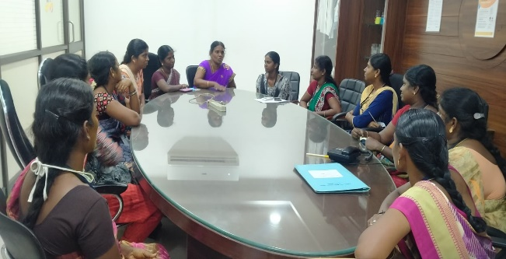
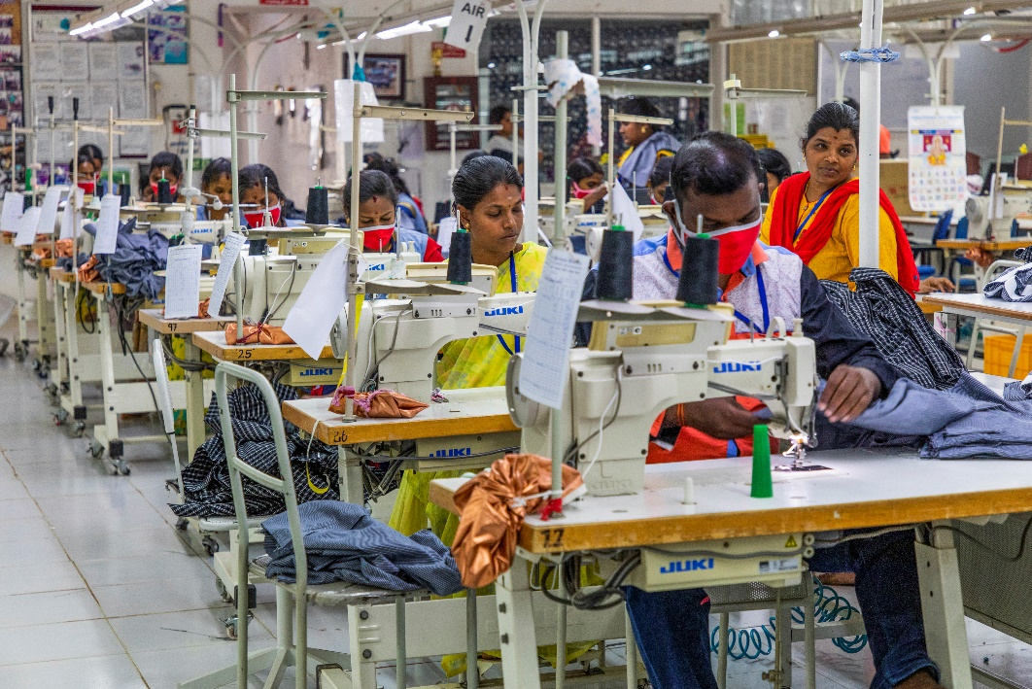
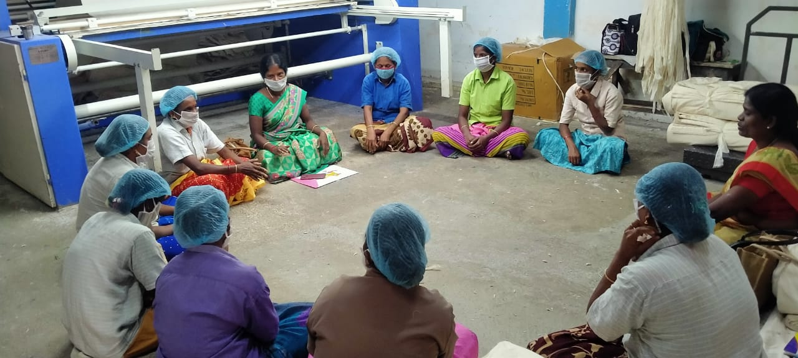

School management committee:
- In Child Voice Nilakottai working in 30 villages in the Nilakottai block. In our working area community support group members gets awareness about the school management committee. The committee's roles and responsibilities and the committee members' power. Last academy year there is a selection for the school management committee members. Our working area community members actively participated in the election and were selected in most of the schools in the Nilakottai block area. Now they are actively in the committee works.
- SMC meetings were organized in Villages Avaiyampatty, Veelinayakanpatty, Musuvanathu, Pillayarnatham, Sivananpuram, Viralipatty, Kokkupatty and Facilitators from Child Voice Nilakottai Project represented in the meeting and discussed the identification of school dropouts, enrolling them back to schools and reducing the child marriages.

Social protection Schemes
Totally 51,849 beneficiaries applied for various social security schemes such as Aadhar correction, Voter id, Birth certificate, Death certificate, Income certificate, Community certificate, and Rs.12/rs.330 Insurance schemes, House Patta, OAP, Labor welfare cards, first-generation graduation cards, E-Shram cards, and Nativity certificates, out of which 49,872 people received the schemes.
HRF:
- In Nilakottai, Dindigul district, in association with Child Voice, the Center for Human Rights Development and Research (Chennai) has started the work of adding social protection programs to the most vulnerable people from five villages: Musuvanathu, Veelinayakanpatti, Kattunayakanpatti, Ethilodu, Mettupatti.
- Villages were surveyed directly. Information was collected from 600 most vulnerable families. Awareness about social security schemes was first given to people. Social security schemes required by them were surveyed
- There are twenty types of social security schemes for the people caste certificate, income tax certificate, old age pension scheme, widows pension scheme, young widows pension scheme, getting Aadhaar card for those who do not have Aadhaar card, adding the name to ration card, and getting VOTER ID etc.,
- About 5000 people were provided with social security schemes by the Center for Human Rights Development and Research and Childvoice team
- Also, 30 widows from these 5 villages were given relief items worth ₹1000 each and children from these 5 villages were given playthings worth ₹20,000.
- Twice the Collector's office was taken to petition the people for common problems, through which the liquor shop near the Govt. School in Anaipatti in our Nilakottai was removed, and bus facility, sewage disposal, drain repair, public toilet, and public health centre were brought into the villages. Most vulnerable people benefited a lot from this. They thanked Child Voice and the Center for Human Rights Development and Research.
S.No | SOCIAL PROTECTION SCHEMES | TOTAL
S.No | SOCIAL PROTECTION SCHEMES | APPLY | RECEIVED
1 | AADHAR | 114 | 95
2 | VOTER ID | 44 | 15
3 | RATION CARD | 203 | 180
4 | COMMUNITY CERTIFICATE | 199 | 182
5 | INCOME CERTIFICATE | 126 | 116
6 | OLD AGE PENSION | 29 | 10
7 | WIDOW PENSION | 25 | 3
8 | DESTITUTE WIIDOW PENSION SCHEME | 21 | 5
9 | Differently Abled Pension Scheme | 20 | 15
10 | PMJAY | 1560 | 1560
11 | E SHRAM | 1870 | 1870
12 | PAN CARD | 226 | 222
13 | EP AADHAR LINK | 964 | 964
14 | FREE BATHROOM | 20 | 5
15 | JOB APPLY | 2 | 2
16 | NATIVE CERTIFICATE | 146 | 146
17 | LEGAL HEIR CERTIFICATE | 3 | 3
18 | SOLVENCY CERTIFICATE | 3 | 3
19 | Small / Marginal Farmer Certificate | 243 | 243
20 | FIRST GRADUATE | 5 | 5
21 | FREE PIPELINE | 32 | 27
22 | FREE HOME | 23 | 0
 | TOTAL | 5878 | 5671
CRE Clubs
Child Voice Operates 5 CRE Clubs in Nilakottai Block and 2 CRE Clubs in Kodaikanal Block
Sl.No | Name of the Club | Members of the Club | Facilitator
1 | Veelinayakanpatty | 20 | Ramajeyam
2 | Thoppupatty | 20 | Pothumai
3 | Kamatchipuram | 20 | Murugeshwari
4 | Noothalapuram | 20 | Santhya
5 | Maniyakaranpatty | 20 | Indrani

Dropout students rejoining the schools:
Child voice working in 10 villages. All 10 villages have an issue with school dropout at the middle school level. Our staff find the dropout children from the working villages. Child voice staff regularly sensations the community members and students to the importance of education. But children are not much interested to go to school at the same time the dropout children’s parents also do not encourage the children to go to school. After CSG formation and training programs, CSG members get involved to rejoin the children in the schools. Adolescent Girls and Boys groups formation and training they also encourage the village friends to come to schools. But still, some children are not going to school. This is a challenge for the organisation.
Eco Club
Child Voice has Environment activities. In 40 villages’ Community resource centres, students started the Eco Club activities like tree planting, Plastic free environments, Street Cleaning, and Weekly eco-activities.
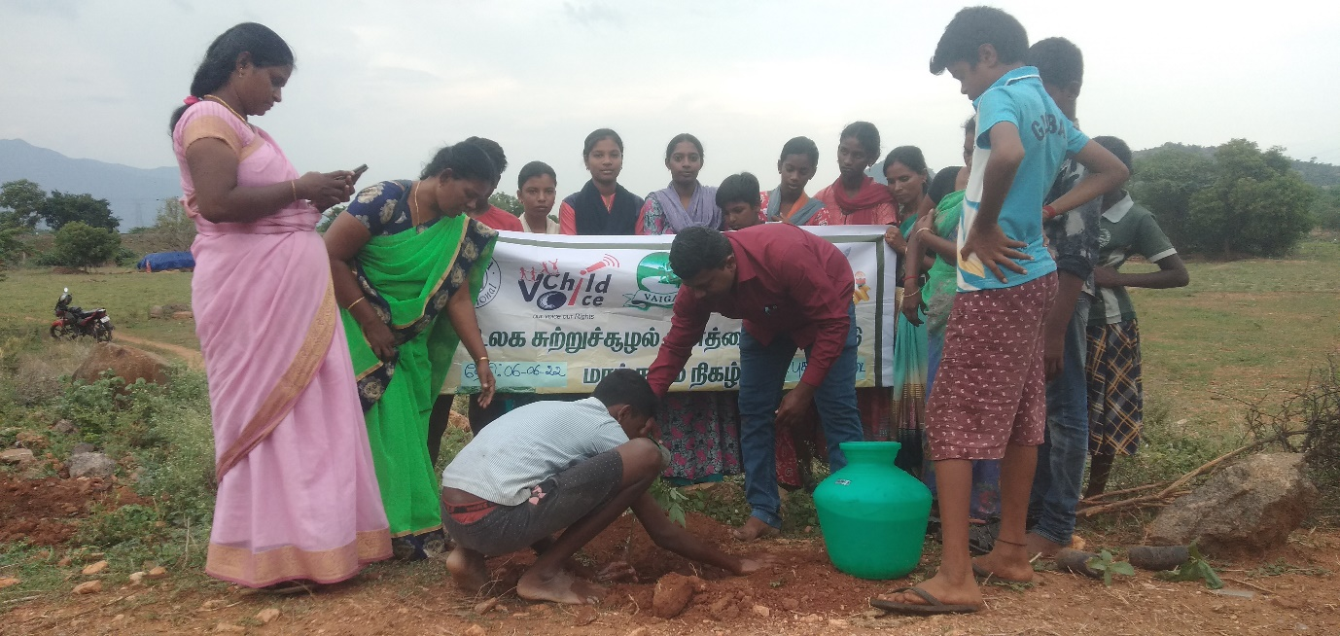

Grama Panchayat Village Libraries
Child-friendly gram panchayat libraries were initiated in 5 panchayats (Veelinayakanpatty, Musuvanathu, Mettupatty, Kullichettypatty and Nariyuthu) at Nilakottai Block. Totally 1325 library books worth Rs.35,075 were supported by Rejuvenate India movement to CRC centres in five panchayats. This child-friendly library will be an added advantage to improving the knowledge of CRC students covered by five panchayats. As part of this programme career guidance also will be given to students who are eligible to go to higher students. In addition, parenting counselling also will be offered. In all five panchayats libraries were opened by Village Panchayat Presidents.
VLCPC
VLCPC's main objective is to protect and promote its rights. Regular meetings are conducted in 7 Panchayats (Musuvanthu, Kullichettipatty, Veelinayakanpatty, Kullalakundu, Nuthalapuram, Pallapatti, Nariyuthu,) in the Nilakottai block to strengthen the functioning of VLCPC. Facilitators and CSG members were added to VLCPC to represent our organizations. In this particular year, a total of 182 members participated in this VLCPC meeting.
It has also joined hands with the District Legal Service Authority, Taluk Legal Service Authority, Department of Police, Department of Integrated Child Development, Department of School Education and Likeminded grass-root NGOs and created mass awareness among on public on the prevention of Bonded Labor and Child Labor system, Human Trafficking in the Villages in and around Nilakottai Block.
VLCPC meeting was conducted in Two Panchayats Veelinayakanpatty and Kullalakundu and the issues of Children were discussed in the meeting, followed by placing the visibility board at the common places in the panchayat to empower the community to protect the children at risk was planned. Totally 26 members along with the general public in Veelinayakanpatty panchayat and 14 members in Kullallakundu panchayat were VLCPCs.
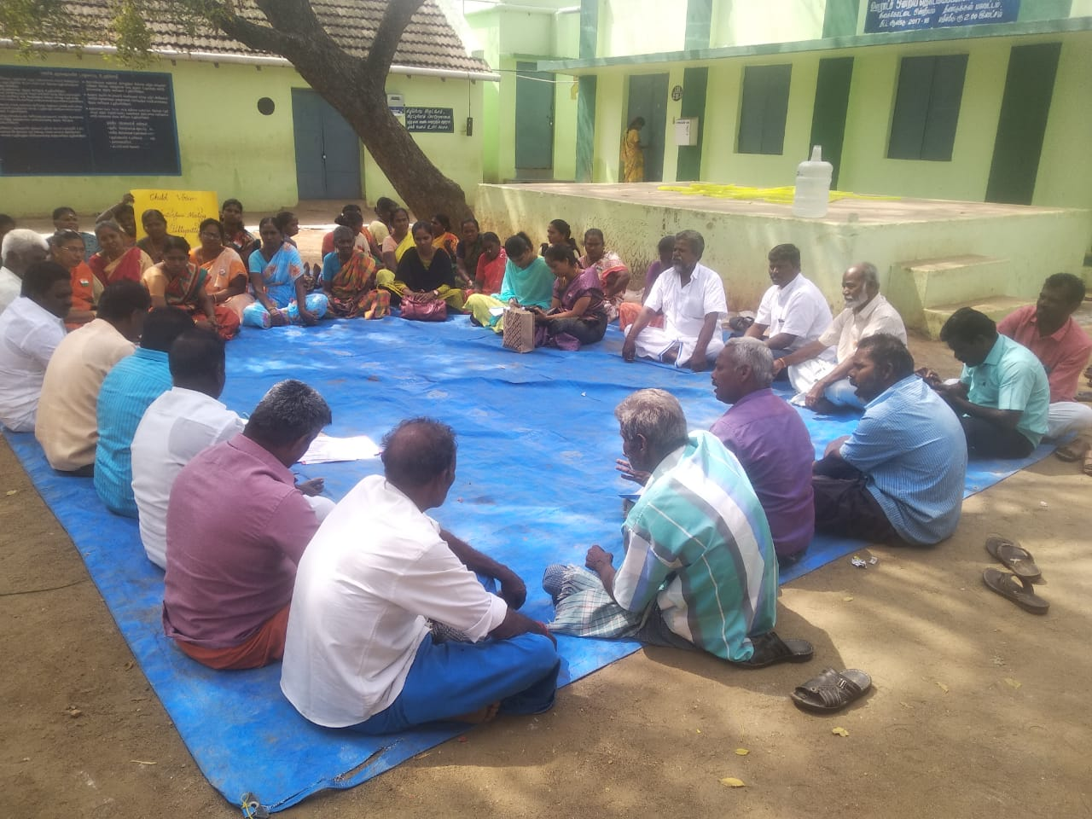
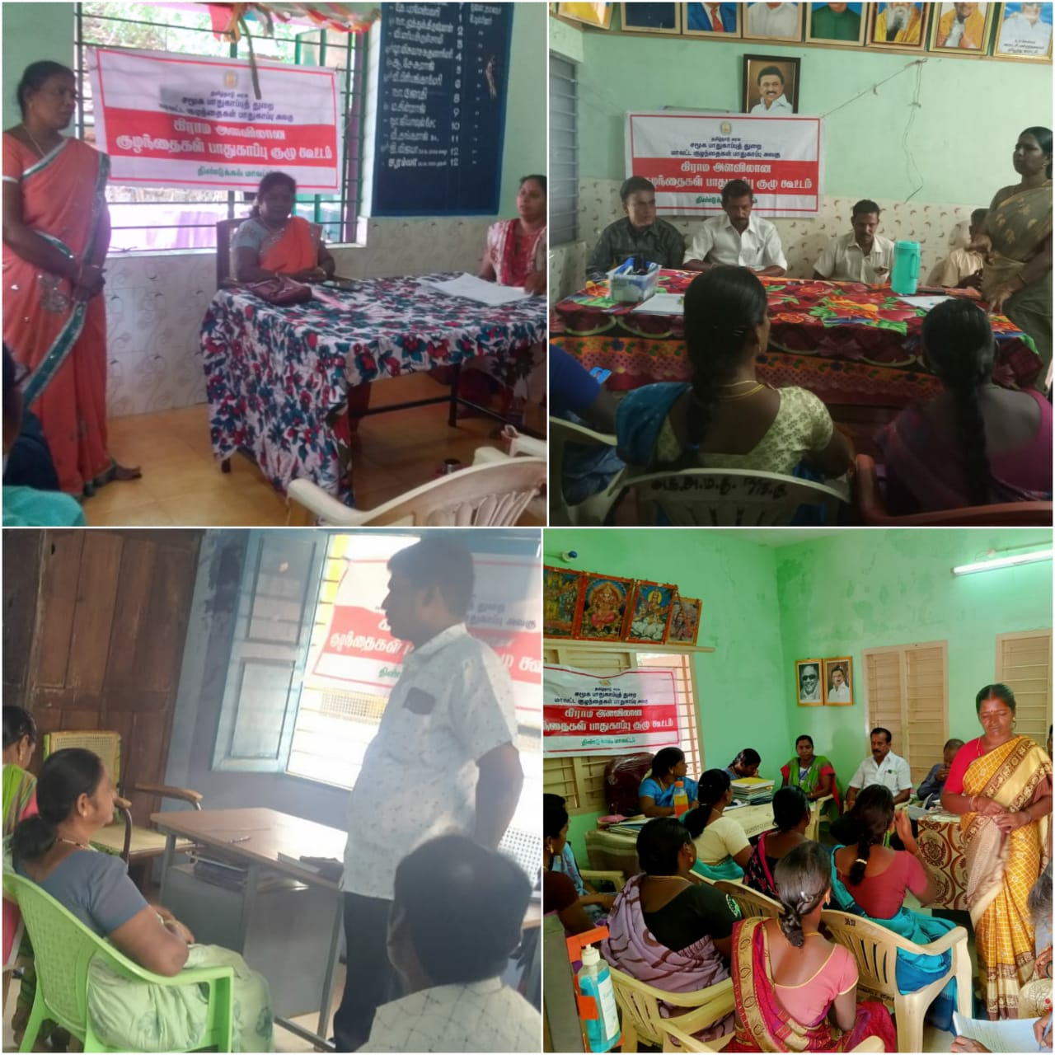

Program with ICDS & DCPU
In collaboration with ICDS (Integrated Child Development Schemes) of Nilakottai Block, an Orientation on Life skills and a career guidance program was provided to Adolescent Girls who are studying in schools and colleges. Annadurai, the Project Director and Mr, Vignesh, the Program Manager were the key resource persons in conducting this training and reached out to 250 adolescent girls from 4 schools and 1 college.
In collaboration with DCPU (District Child Protection Unit) of Dindigul district. This program was to awareness about Childline and Post carts to the district collector. This post-cart awareness is for if the child has some problem in their family or any other issues they can directly write a letter to the district collector.
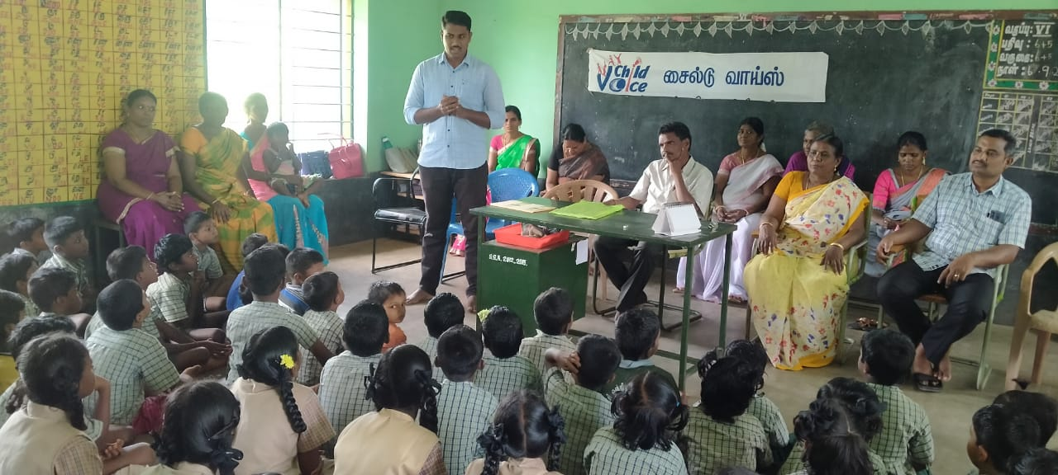

-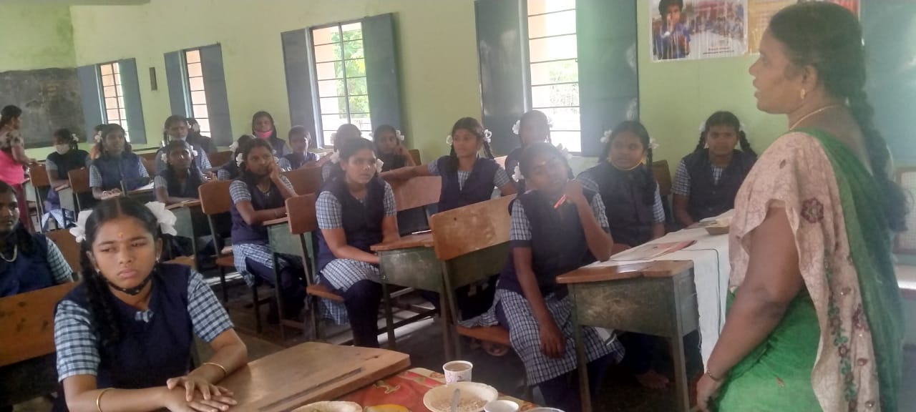

Internal committee
Child Voice formed an Internal Committee in 16 Garments and Spinning Mills in Vadipatti textile park, Vilathur, Pallapatti and Nilakottai block area. This committee was arranged to prevent sexual harassment at the workplace, and also to train staff members on POSH Act. Quarterly meetings of IC were organised by Child Voice in these 16 companies. A regular follow-up visit was carried out by the staff members of Child Voice in these companies with regard to counselling, training, and meetings, based on the need raised by the company for the benefit of staff members. All the meetings were done with the support of the Management of the Company and staff members. Internal Committee meetings in Garment factories had been conducted and orientation was given to IC members on the Prevention and prohibition of Sexual harassment at Workplaces. Worker’s Support had been formed.
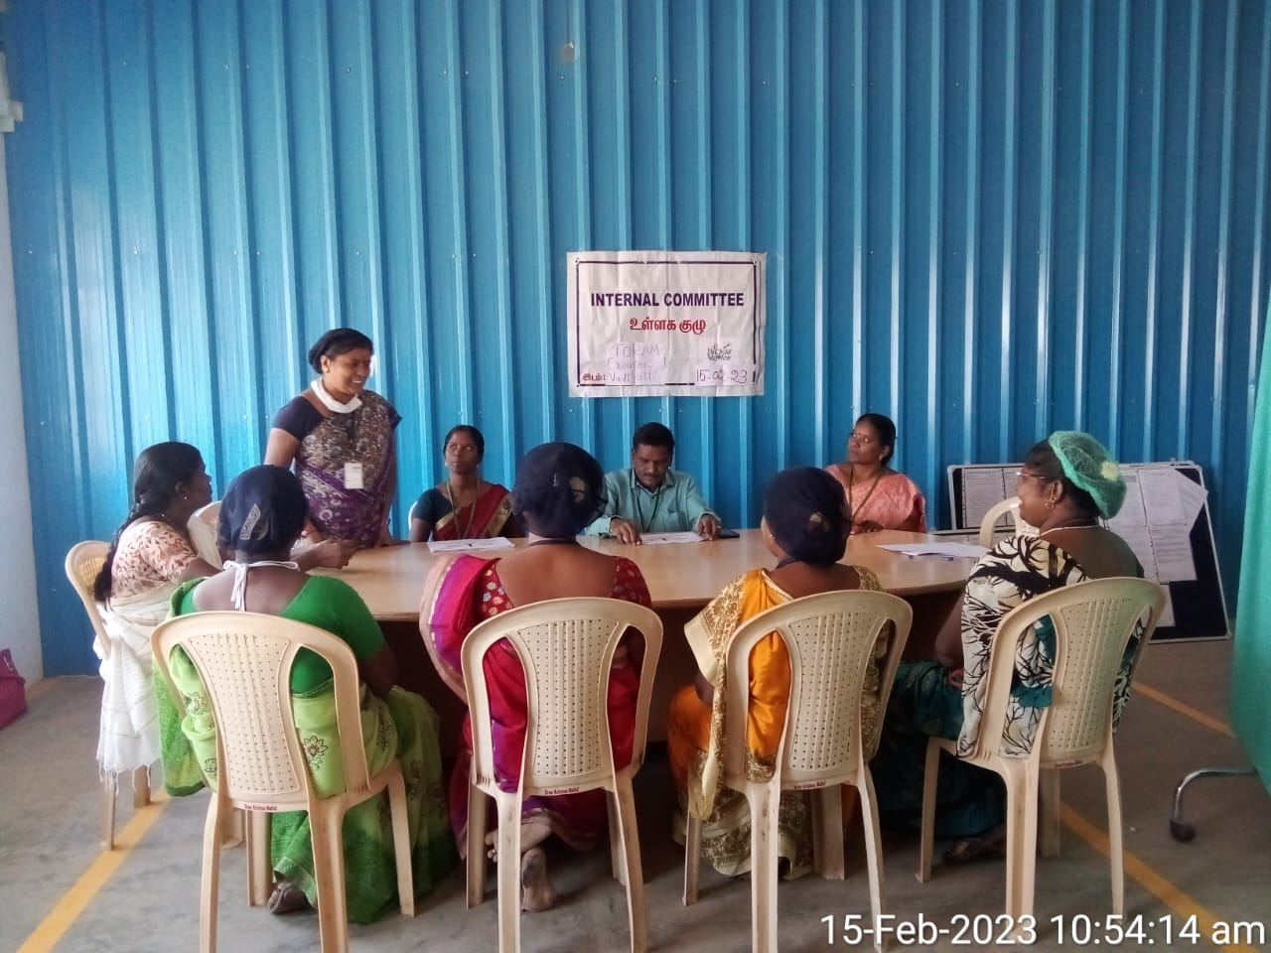
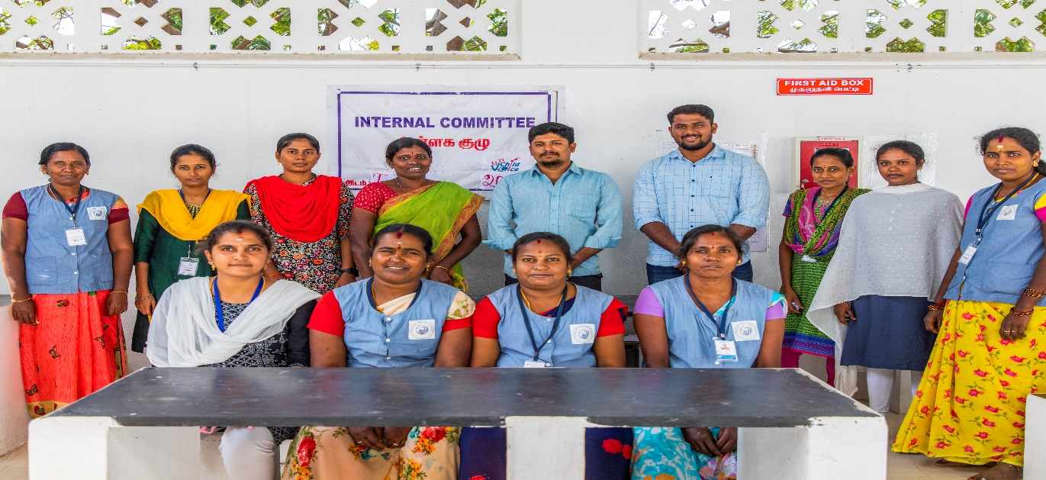
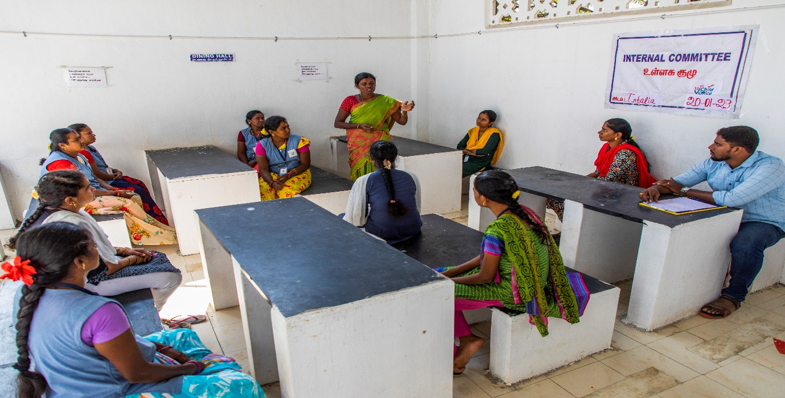
Health Camps
Child Voice Nilakottai project organized Health Camps with local panchayats and the Health Department to reach out to the community people in 40 working villages in Nilakottai Block. Totally 11 camps are conducted at Pallapatti, Mavuthanpatti, Nagayagoundanpatti, Kamachepuram, Ammapatty, Indiranagar, Quality Unit I &II garments, Intalia garments, SDM spinning mill. In the health camp, a total of 2618 community people benefited. This Health camp was organized in the villages in presence of the Panchayat president, Primary health centre doctors, Health inspectors and Village health nurses.
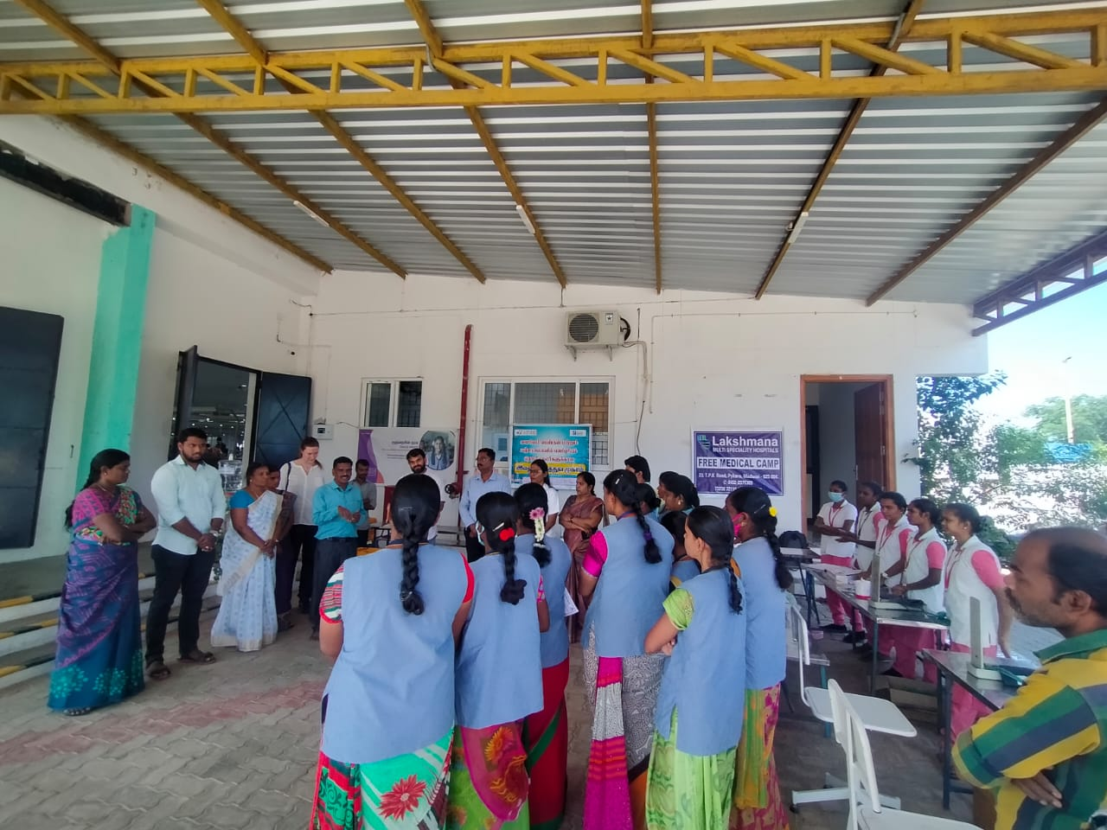
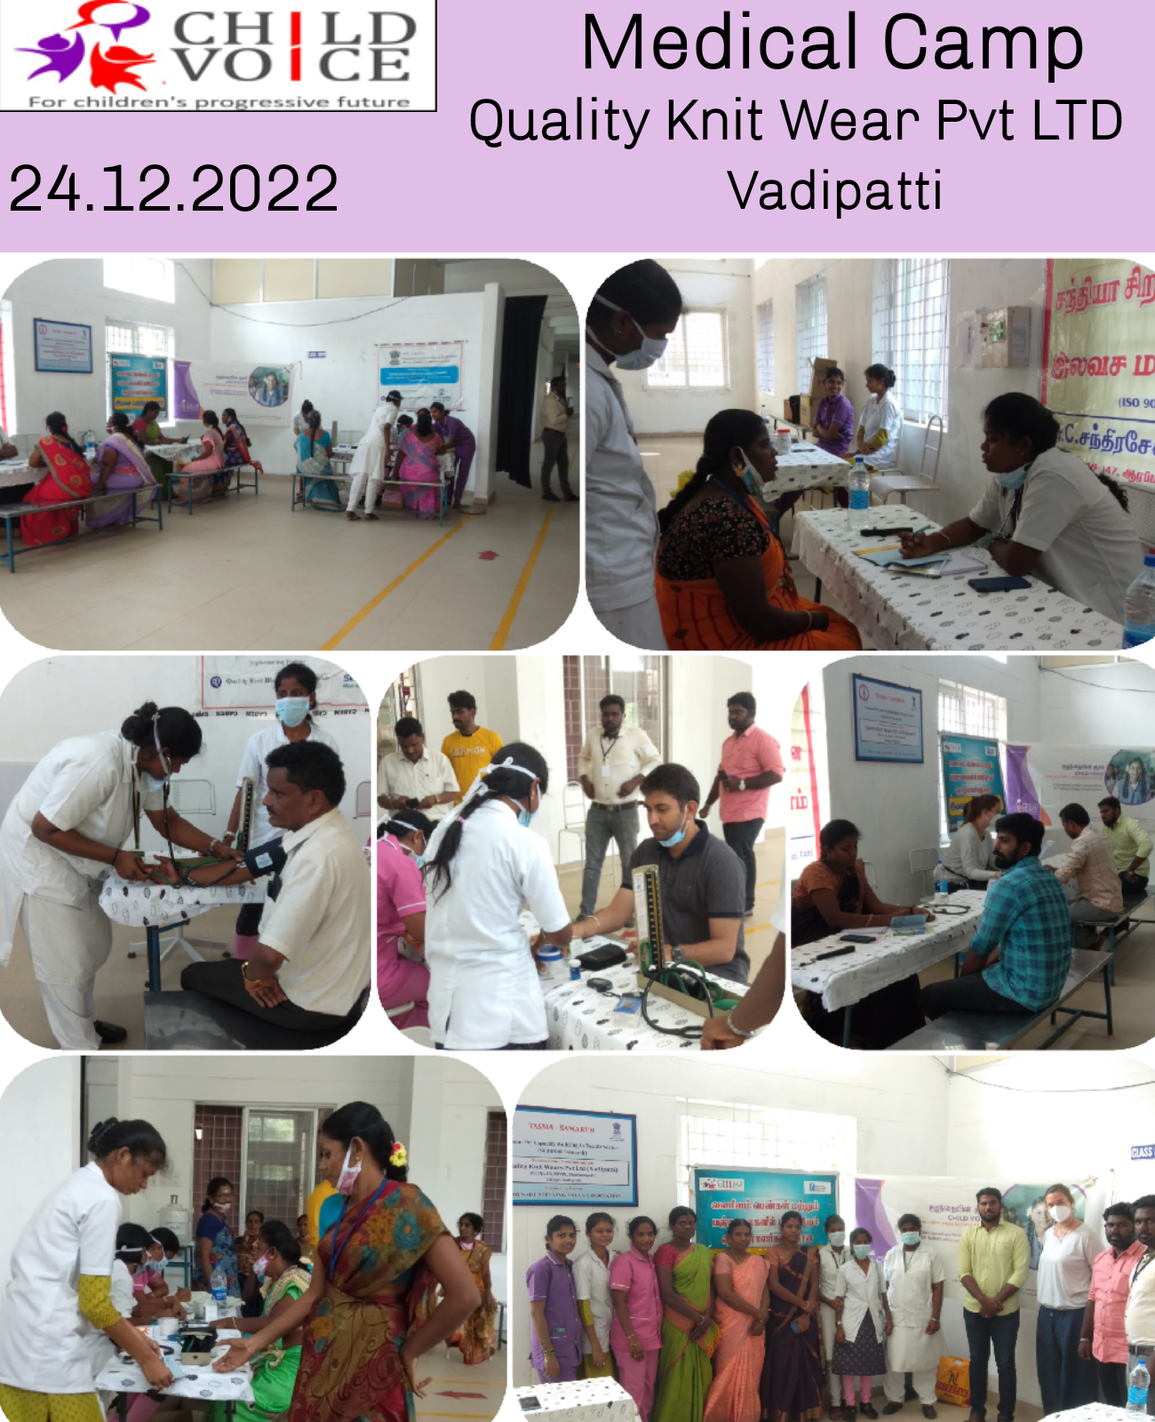
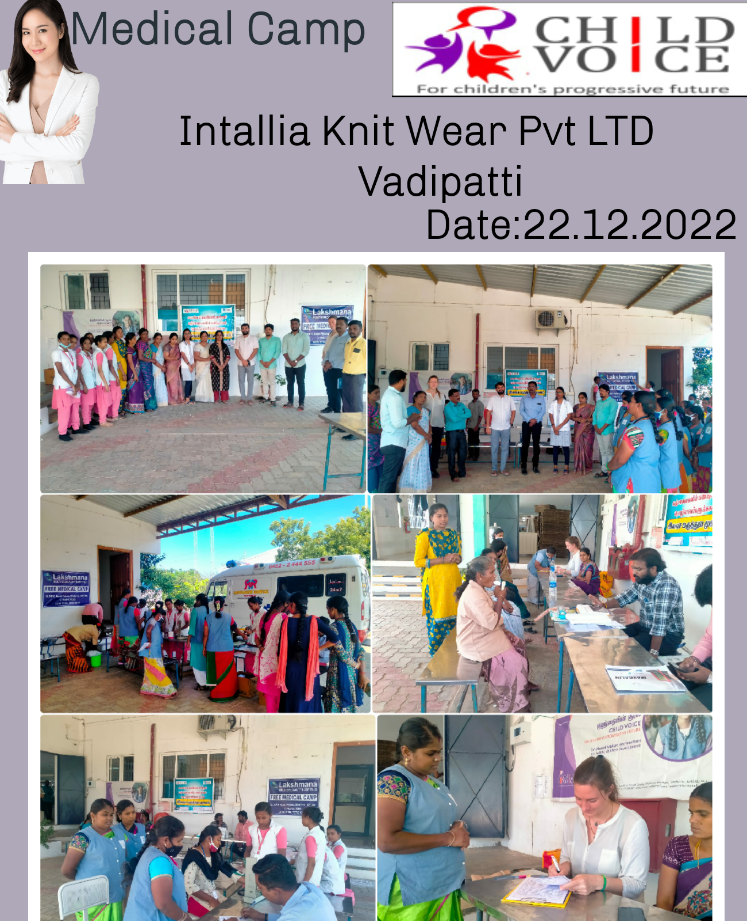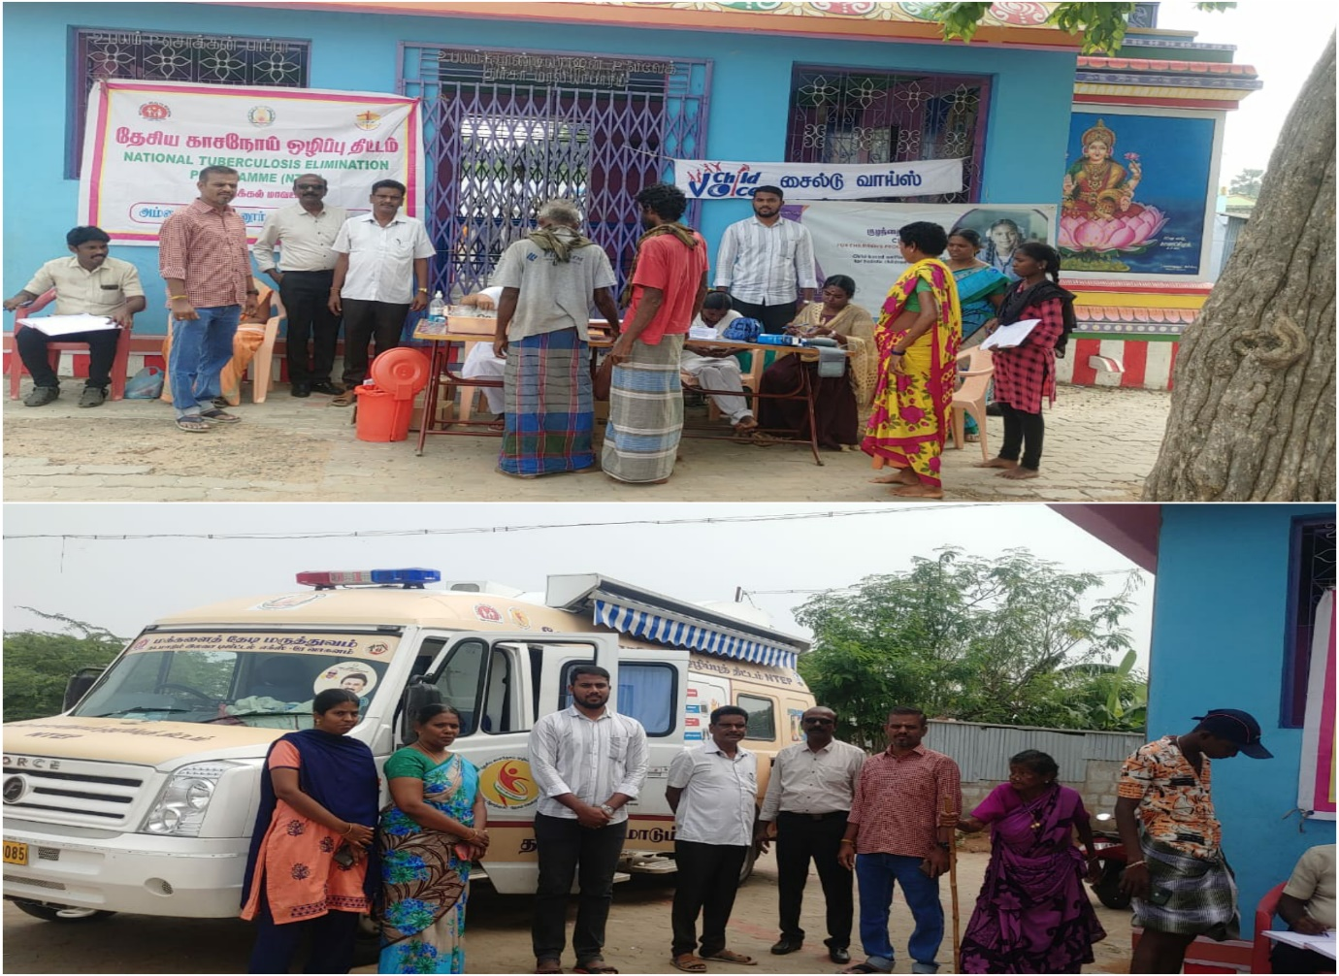

Observation of Important days
Important days were observed in working villages by AAG, ABG, CSG and workers’ support groups from April 2022 to March 2023. The following important days were observed in villages
April 2022 to March 2023
22.04.2022- Earth Day.
01.05.2022-International Labour Day
01.05.2022- Anti Tobacco Day.
12.06.2022-Anti Child Labour Day
21.06.2022-International Yoga Day
30.07.2022- Anti-Human Trafficking Day
15.08.2022-Independence Day.
15.09.2022-International Day of Democracy.
15.10.2022- Hand Washing Day.
14.11.2022- Children’s Day.
19.11.2022- Toilet Day.
10.12.2022- Human Rights Day.
18.12.2022- Migrant Day.
15.01.2023- Pongal Day.
24.01.2023- National Girl Children Day.
26.01.2023- Republic Day.
03.02.2023- Cancer Day.
09.02.2023-Bonded Labour Abolition Day.
08.03.2023- Women’s Day.
22.03.2023- Water Day.
Totally 1547 Community people participated in these important days observed in the villages by AAG, ABG and CSG members along with our staff members.
Internship programme for college students
Sl.No | Name | Department | College | Duration
01 | Miriam Ostreich | Student of Heidelberg University  Public Relations and Event Manager at the Max Planck Foundation for International Peace and the Rule  of Law | From Germany | 19 November to 30 December 2022.
02 | I.Gowtham | BSW II year | Anaugraha Institute of Social Sciences | ^{10th} January 2023 to 28th March 2023.
03 | S.Kevin Arulanand | BSW II year | Anaugraha Institute of Social Sciences | ^{10th} January 2023 to 28th March 2023.

Staff Meetings and Training
In child voice every month first week we have our Project staff monthly review meeting. In the meetings, we discussed the last month all activities done by themselves, achievements and challenges, SPS registration and planned for next month’s activities. Sometimes there is a training program for the project staff about Adolescent groups activities and reports submission.
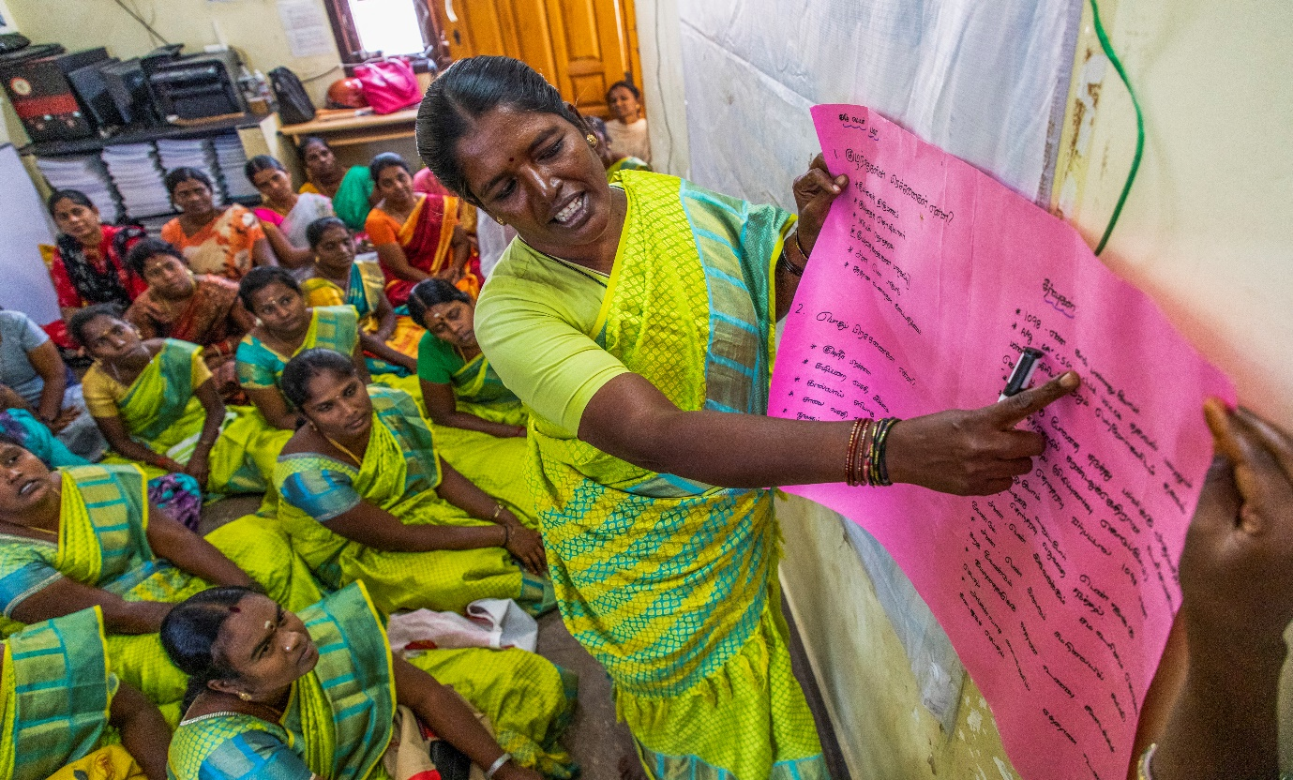
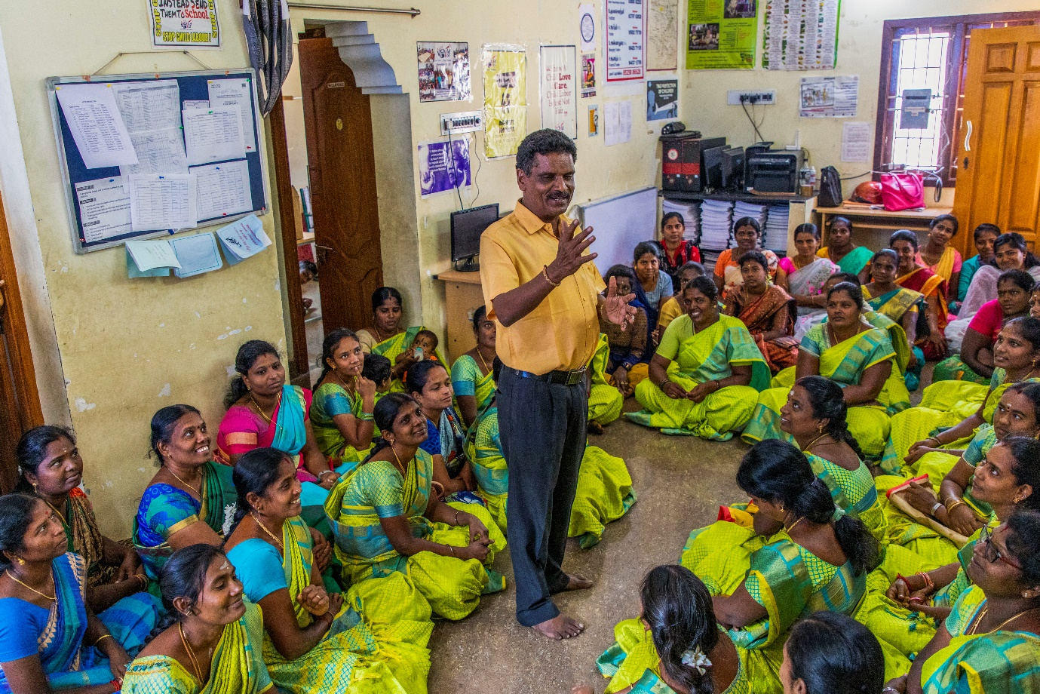
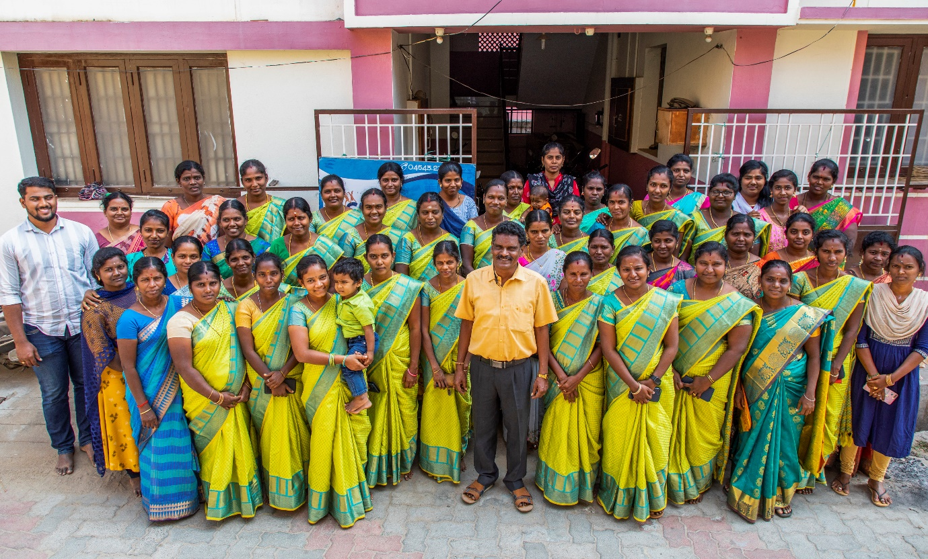

Media clippings
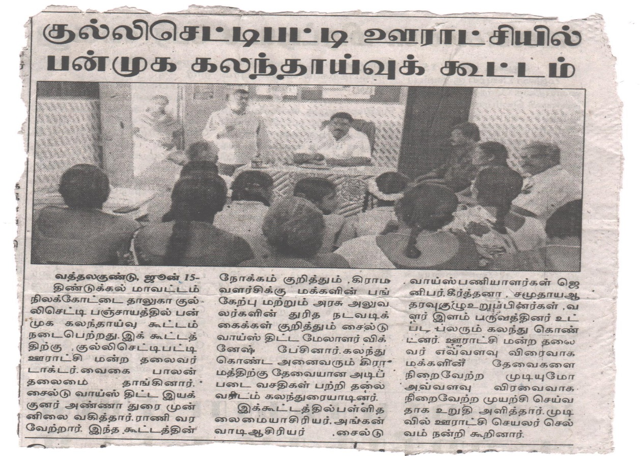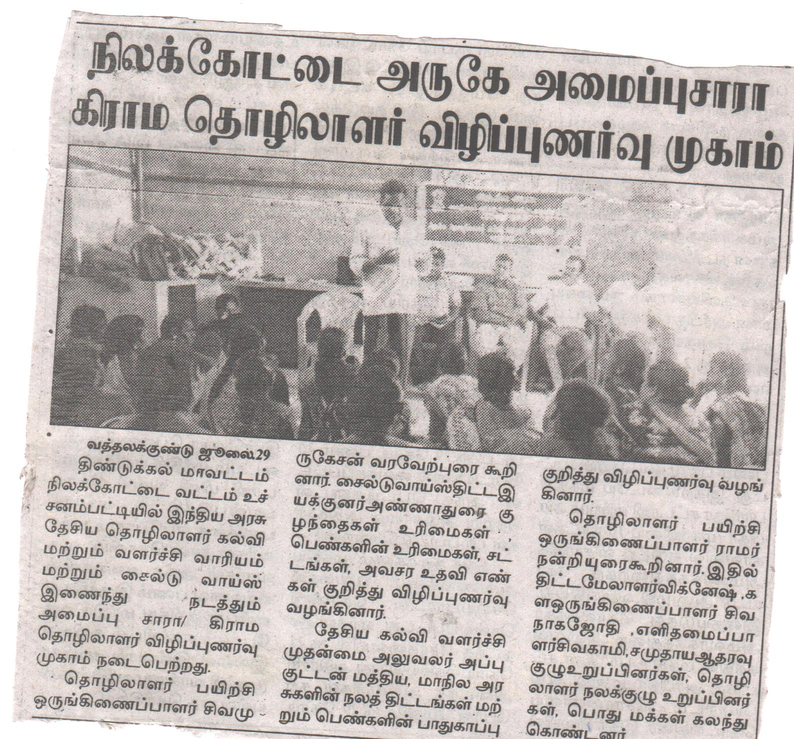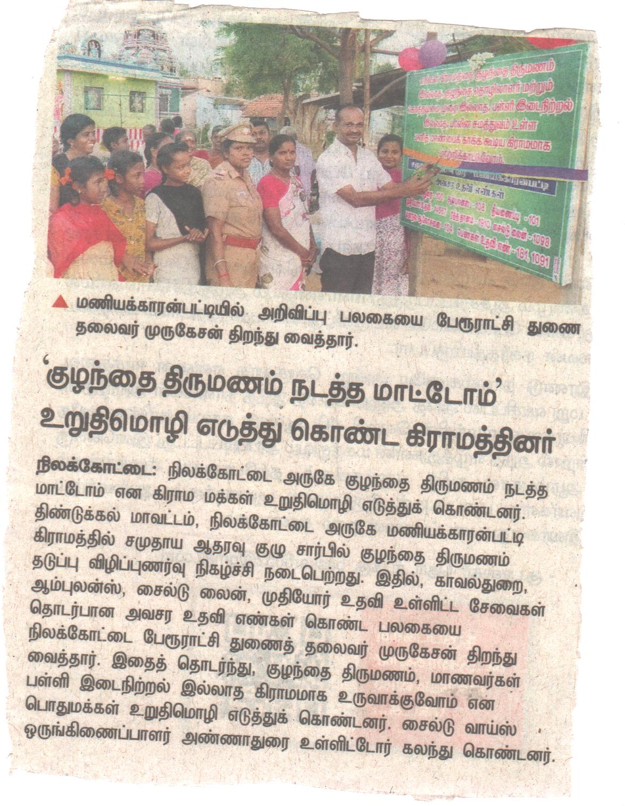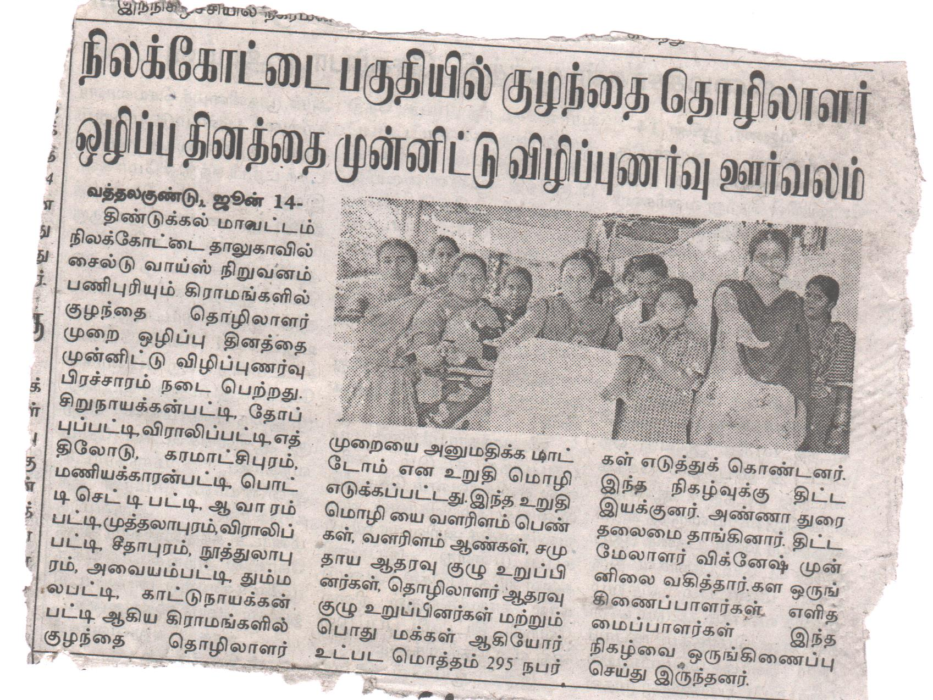
Case Study
Name: Chitra
Age: 17
Father‘s Name: Ganeshan.
Mother’s Name: Amutha.
Village: Old Silukkuvarpatti, Nilakottai.

Family situation: Chitra, 17 years old, has been living in the old silukkuvarpatti village. She has an elder brother. She has a single-parent mother only. Her father left the family. Her mother worked in the spinning mill but now she couldn’t go to work due to her health issues she became a survivor. Chitra completed higher secondary school but she couldn’t go to school because of her family situation. After this project started our staff found Chitra and study her family situation and suggested education support. Child voice gave education support to Chitra and now she is purchasing B.A (Tamil), Govt women’s Art and science college, kulathupatti, Nilakottai.
Change: Now, Chitra is purchasing B.A (Tamil) through this education support. She supports our community resource centre evening tuition centre to take classes for high school students.

Name: Priya Dharshini
Age: 15
Father’s Name: Priyamuniyandi.
Mother’s Name: Ramuthai.
Address: East Street, Sivagnapuram, Kullichettypatti (PO), Nilakottai (TK), Dindigul.
Family situation:
Her mother works as a wage earner. Father works as a wage earner. She is studying 9th standard in a school in the Theni district in the academic year 2020 to 2021. Later, due to a family situation, she moved to Shivananapuram village near Nilakottai. His parents took him back to school at a nearby school. The school refused to admit her to school for the name on her Aadhaar was Priyamani instead of Priyadarshini. Changing her name was a big challenge for her parents.

Intervention:
Then the name was changed with the help of our facilitator. After 1 year now she is studying at Govt Kallar Higher Secondary School in Anaipatti.
Changes:
Now, she is grateful to Child Voice, Nilakottai for helping to continue her studies at the Kallar Higher secondary school.
Name: Pecheammal
Age: 19
Father‘s Name: Murugan.
Mother’s Name: Chellammal.
Guardian Name: Dhanasekaran. (Elder brother)
Village: Veeralipatti, Nilakottai.

Family situation: Pecheammal, 19 years old, has been living in the Veeralipatti village. She is with her elder brother because her father and mother are passed away. Chitra completed higher secondary school but she couldn’t go to college because of her family situation. Her brother also doesn’t have a proper job for his livelihood. So Pecheammal doesn’t have the opportunity to join college she starts to go millwork. Peace trust nilakottai staff found Pecheammal and study her family situation and suggested education support. Peace Trust Nilakottai to give education support to Chitra and now she is purchasing B.B.A. Govt Women’s Art and Science College, kulathupatti, Nilakottai.
Change: Now, Pecheammal is purchasing B.B.A. through this education support. She supports our community resource centre evening tuition centre to take classes for high school students.

